SERVICE BULLETIN RECALL:
DC/DC Converter Inspection / Replacement
NHTSA Campaign Number: 16V-???
Purpose
Zero Motorcycles has determined that a defect which relates to motor vehicle safety exists on certain 2015 Model Year SR, S, DS and FX model motorcycles built between April 27, 2015 and August 21, 2015. The subject motorcycles were potentially assembled with a DC-DC converter that may have insufficient power output margin. If a DC-DC converter does not have enough power output margin to support all foreseeable power demands, including most of its accessory outlet capacity, it may temporarily shut off when its power capacity is exceeded, with no prior warning to the rider. Should this occur during an Anti-Lock Braking System (ABS) activated event, the ABS and all vehicle lights would temporarily stop functioning, which could increase the risk of a crash. Zero Motorcycles has voluntarily initiated this recall to correct this condition. The remedy of this defect is for an authorized Zero Motorcycles dealer to inspect and replace the DC/DC converter on suspect vehicles.

As required by law, you may sell but NOT DELIVER any affected motorcycles to your customers until the remedy is completed.
Applicable Models
The recall population of 96 motorcycles includes:
- 2015 model year Zero SR model motorcycles built 8/5/2015 through 8/6/2015
- 2015 model year Zero S model motorcycles built 5/7/15 through 6/17/15
- 2015 model year Zero DS model motorcycles built 4/27/15 through 8/21/15
- 2015 model year Zero FX model motorcycles built 5/4/15 through 8/19/15
This covers the entire range of motorcycles potentially containing the subject defect.
Tools Required for Inspection
- 3mm Hex Key (for FX models)
- Flashlight

Parts Required
- 60-07190 DC-DC CONV 500W SEVCON (only if suspect DC/DC is found)
Procedure
The suspect DC/DC converters have open slots on the mounting bracket. The non-suspect DC/DC converters have a closed bracket.
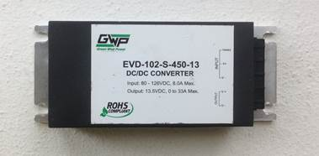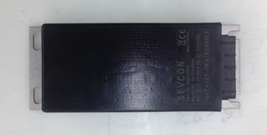
SDS Inspection
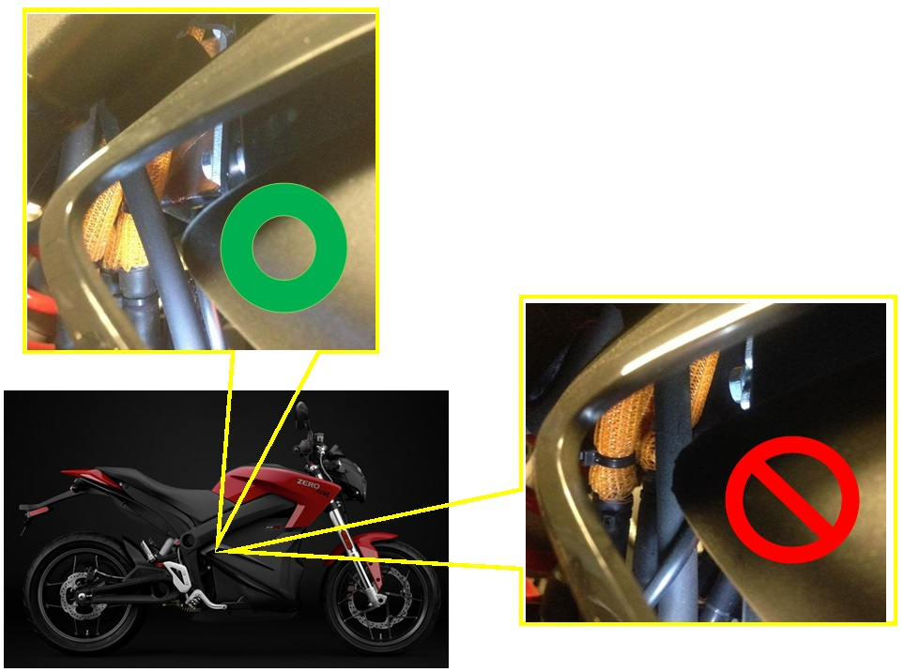

FX Inspection
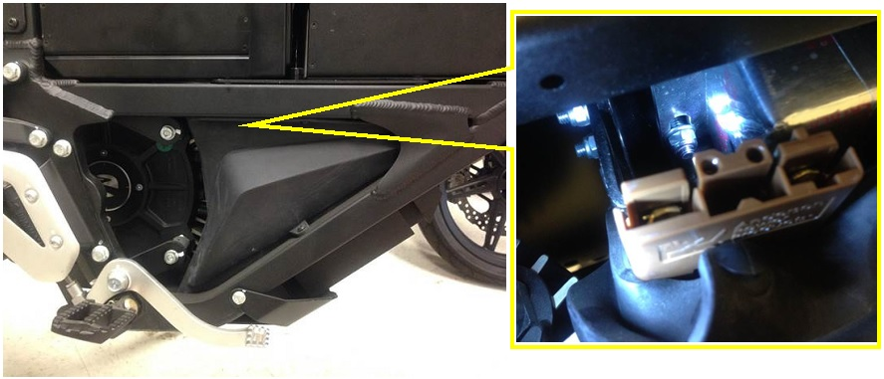
If a slotted bracket is found, the DC/DC converter must be replaced. The procedure for replacement can be found on the service.zeromotorcycles.com website under the applicable model.
Customer Notification
In accordance with Federal regulations administered by NHTSA, Zero Motorcycles Company will send a letter to registered owners of affected products, notifying them of this safety-related condition and instructing them to contact their Dealer for the associated remedy. A sample of the customer letter is attached. Zero will also try to contact these customers by telephone.
To protect the safety of our riders, it is our mutual responsibility to ensure the recall upgrade is performed on all affected motorcycles. Therefore, we strongly encourage you reach out to your customers to make sure that they are aware of this program. You are also required by law to perform the recall service on all affected motorcycles in your inventory prior to delivery to your customers.
If you are aware of any unregistered owners of this affected motorcycle population, please advise us of their names, addresses and VINs, so that we may mail them the owner’s letter, as required by NHTSA.
If you are not sure that this safety recall has been performed on a particular motorcycle, please contact Zero Motorcycles Customer Service for verification.

Sample Owner Communication:
IMPORTANT SAFETY RECALL NOTICE

This notice applies to your vehicle VIN# XXXXXXXXXXX

August XX, 2016

Dear Zero Motorcycles Owner,

This notice is being sent to you in accordance with the requirements of the National Traffic and Motor Vehicle Safety Act.

Zero Motorcycles has determined that a defect which relates to motor vehicle safety exists on certain 2015 Model Year SR, S, DS and FX model motorcycles built between April 27, 2015 and August 21, 2015. The subject motorcycles were potentially assembled with a DC-DC converter that may have insufficient power output margin. If a DC-DC converter does not have enough power output margin to support all foreseeable power demands, including most of its accessory outlet capacity, it may temporarily shut off when its power capacity is exceeded, with no prior warning to the rider. Should this occur during an Anti-Lock Braking System (ABS) activated event, the ABS and all vehicle lights would temporarily stop functioning, which could increase the risk of a crash. Zero Motorcycles has voluntarily initiated this recall to correct this condition.

Our records indicate that you purchased one of the motorcycles listed above.

We strongly urge you to contact your Zero Motorcycles dealer to make arrangements to have the appropriate service performed as soon as possible. Should you choose to ride your motorcycle prior to this service, we urge you to be aware of this condition.

The remedy of this defect is for Zero Motorcycles dealers to inspect the potentially affected motorcycle population for having been assembled with one of the suspect DC-DC converters and replace it if confirmed. Should you choose to ride your suspect motorcycle prior to having your dealer perform this recall, you should avoid running any accessories on the accessory outlet.

Please contact your Zero Motorcycles dealer immediately and arrange an appointment to have your motorcycle repaired. The actual dealer labor time to perform this service will be approximately 1 hour and 15 minutes; however, due to scheduling, the dealer may require your motorcycle for a longer period of time. The parts and labor will be free of charge to you. Replacement parts are now available for order by your dealer.

If you no longer own this motorcycle, please contact us at 1-888-841-8085 so we may update our records and notify the new owner. Federal regulation requires that any vehicle lessor receiving this recall notice must forward a copy of this notice to the lessee within ten days.

If you have had this defect repaired before you received this letter, you may be eligible to receive reimbursement for the cost of obtaining a pre-notification remedy of the problem associated with this recall. For more information contact Zero Motorcycles at 1-888-841-8085.

If your dealer or Zero Motorcycles fails or is unable to remedy your motorcycle without charge within a reasonable time, you may wish to inform the Administrator, National Highway Traffic Safety Administration, 1200 New Jersey Avenue, SE, Washington, DC 20590, or call the toll-free hotline at 1-888-327-4236 (TTY: 1-800-424-9153); or contact NHTSA at http://www.safecar.gov.

We regret any inconvenience this may cause you, but we are initiating this action in the interest of your personal safety and satisfaction with our products. Thank you for your cooperation.

Sincerely,

Aaron Cheatham
Director of Customer Service
Zero Motorcycles Inc.
Warranty Claim Reimbursement
To receive reimbursement for the work performed under this service campaign, the dealer must submit a Service Bulletin/Recall Warranty Claim for the part and labor hours incurred with the following information:
- Fault Summary: MY15 DC/DC Inspection/Replace Recall
- Fault Area: 50-DC/DC Converter
- Fault Code: 91-Service Bulletin Recall
- Service Bulletin/Recall: SV-ZMC-016-356 – MY15 DC/DC Inspection/Replace Recall
Zero Motorcycles believes that the time that should be allotted for this work is 15 minutes (0.25 hours) for inspection only. For inspection and replacement, the time is 1 hour and 15 minutes (1.25 hours). We do not reimburse any costs related to loaner or temporary replacement motorcycles or other vehicles.

